Original article
Ai-MAST Conference Paper Template
Gyei-Kark PARKª, S. June KIM^{b}
ª Dept. of Logistics and Maritime Studies, Mokpo National Maritime University, Korea, gkpark@mmu.ac.kr
^{b} Dept. of Liberal Arts and Science, Mokpo National Maritime University, Korea, sjunekim@mmu.ac.kr, Corresponding Author

Abstract
The abstract is up to 300 words in English. It shall outline the aims, scope, methodology and conclusions of the paper. Contributions of the paper are desirable but not compulsory.

Keywords: Sample paper, MS Word (no more than 6 keywords)

☆(Do not DELETE)

1. Introduction
For consistency and inclusion in the Conference Proceedings and Journal, all papers prepared must adhere to the format as set out in this paper template. Papers which do not conform to the stated requirements may not be published in the Conference Proceedings and Journal. Authors are strongly advised to prepare their papers by editing a downloaded copy of this file. Main text

2. Paper Submission
Papers should be submitted in electronic form (Microsoft Word) as an attachment by e-mail to Managing Editor S.June KIM, s-junekim@daum.net // e-navi@e-navigation.kr by the deadline.

3. Typing Instructions
Font size should be in 11 pt Times New Roman throughout the text, except for the title and authors and footnotes (see below).

4. Paper Size
Page size must be set to A4 Size. Set the margins of your document to Moderate.

5. Quotations
The sources of all non-original data/information must be quoted. Articles which have been co-authored by two authors must be fully quoted, while articles which have been co-authored by three or more authors should be quoted as “(first author, p.12) et al.” The cited page number might be omitted if not necessary. For example:
According to Bagchi and Virum (1996), alliance would start to flourish within the logistics industry in the 21st century, although Meersman et al. (2005, p.12) have warned “whether such scenario would take place highly depends on port efficiency,” of which such view has been supported by the experience of Indian ports (Dayal, 2006).

6. Footnotes
Do not use the footnote unless it is necessary.
Font size 10 pt and justified to the full width of the column; Times New Roman. Footnotes should be kept to a minimum (not more than 10) and as short as possible.

7. Page Limits
The page limit for contributed papers is ten (10) pages, including abstract, figures and tables, list of references, as well as appendices.

8. Title and Authors
Title (14 pt, bold), Authors (11 pt, italic), Affiliations (11 pt). The title should be in lower case with the first letter of major words capitalized. Avoid forcing a line-break unless absolutely necessary. Author affiliations should consist of “Department, Institution, City, State (if applicable), Postcode (if any), Country”. Author affiliations should be noted using superscripts as above. However if there is only one affiliation, please delete the superscript from your file.

9. Section Headings and Subsection Headings
Section and subsection headings should be in lower case with the first letter of major words in upper case. Subsection Heads should be italic. For example:

4.1. 1st Level Subsection Headings

4.1.2. 2nd Level Subsection Headings

10. Equations and Formulations
Equations are to be numbered consecutively from Eq. 1 to the end of the paper including any appendices. Use the equation number when referring to equations, e.g., Eq. 1, Eqs. 2-3. Please take care to type equations accurately. Equations should be 10-point and left-justified. Enclose equation numbers in parentheses and place flush right with right-hand margin of the column. For example:
Min (1)
s.t.
(2)
(3)

11. Figures and Tables
All Figures and Tables should appear in the text near to where they are first referenced. They should be centered between the margins, and must not fall outside of the normal printed area of the page. The font size for all numbers and letters in the figure, as it appears in your paper, must be at least as large as that for the running headings (which use 10 pt).
Give suitable captions above/below the table and/or figure. Captions should be centered. Refer to figures and tables as in “Figure 1, Table 1”.
Please take some care to ensure that the tables (or figures) do not appear out of sequence. Some rewriting may be required to produce the desired effect. Tables can be constructed using the Table commands provided by Word:
SI Units must be used for all weights and measures. If other units are used, the equivalent SI Unit should be included.

Table 1: Example of a table Note that it is centered
IFSPA
1 km | 2 kg | 3 TEUs | 4 nm
1 km | 20 kg | 200 TEUs | 300 nm
3 km | 30 kg | 30 TEUs | 30 nm
Source: Author(s) of the original source (publication year), p.12.

The contents of tables and figures should be clear and self-explanatory with an appropriate caption. If a particular table/figure is quoted from another source, please state the source clearly.
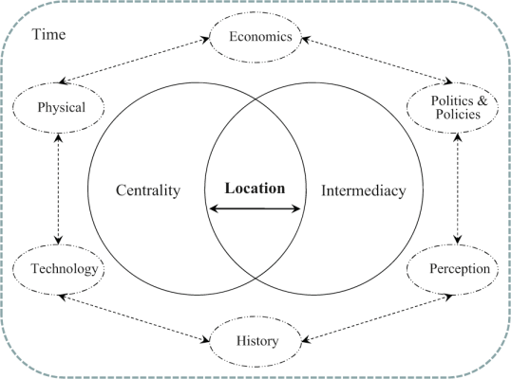
Figure 1: Import Meta File
Source: Author(s) of the original source (publication year), p.34.
12. Conclusions
A brief summary of your research results and/or contributions should be included at the end of the paper.
Submitted: July 24, 2014; Accepted: October 6, 2014

13. Acknowledgements
Acknowledgements and Reference heading should be left justified, bold, with the first letter capitalized but have no numbers. Text below continues as normal.

References
Bagchi, P. and Virum, H. (1996), European logistic alliances: a management model, International Journal of Logistics Management(Journal’s title in italic), Vol. 7, No. 1, pp. 93-108.
Brooks, M. R. (2000), Sea Change in Liner Shipping(Book’s title in Italic), Pergamon: Amsterdam.
CAPGEMINI Netherlands B.V. (2006), Europe’s most wanted distribution centre locations, internal document, unpublished.
Daskin, M.S. (2003), Facility location in supply chain design, Working paper, Department of Industrial Engineering and Management Services, Northwestern University.
Dayal, R. (2006), Promoting Dry Ports as a means of sharing the benefits of Globalization with inland locations, E/ESCAP/CMG (3/1)1, UNESCAP Committee on Managing Globalization.
Meersman, H., Van de Voorde, E. and Vanelslander, T. (2005), Ports as hubs in the logistics chain, In: H. Leggate, J. McConville and A. Morvillo (eds.), International Maritime Transport: Perspectives, Routledge: London, pp. 32-45.
Far East Freight Conference’s website: www.fareast freightconference.com, last accessed in September 2008.

There is no conflict of interest for all authors.

Appendices
All appendices should be placed right after the list of references. If there is more than one appendix, they should be identified as A, B, etc. Formulae and equations in appendices should be given separate numbering: Eq. (A.1), Eq. (A.2), etc.

14. Proofreading Cost
It might be charged for the papers to be revised by the Proof-Readers for their revision at the rate of US$ 100 per page.

Footnote.

